NAME: Ramya Ramesh

USN: 1BM19CS227

**PROGRAM 8: STUDENT ENROLLMENT DATABASE**

TABLES:

CREATE DATABASE student_enroll;

USE student_enroll;

CREATE TABLE student(

regno VARCHAR(15),

name VARCHAR(20),

major VARCHAR(20),

bdate DATE,

PRIMARY KEY (regno));

DESC student;

CREATE TABLE course(

courseno INT,

cname VARCHAR(20),

dept VARCHAR(20),

PRIMARY KEY (courseno));

DESC course;

CREATE TABLE enroll(

regno VARCHAR(15),

courseno INT,

sem INT,

marks INT,

PRIMARY KEY (regno,courseno),

FOREIGN KEY (regno) REFERENCES student(regno),

FOREIGN KEY (courseno) REFERENCES course(courseno));

DESC enroll;

CREATE TABLE textbook(

book_isbn INT,

book_title VARCHAR(20),

publisher VARCHAR(20),

author VARCHAR(20),

PRIMARY KEY (book_isbn));

DESC textbook;

CREATE TABLE book_adoption(

courseno INT,

sem INT,

book_isbn INT,

PRIMARY KEY (courseno,book_isbn),

FOREIGN KEY (courseno) REFERENCES course (courseno),

FOREIGN KEY (book_isbn) REFERENCES textbook(book_isbn));

DESC book_adoption;

INSERT INTO student VALUES('1BM11CS001','A','Sr','19931230');

INSERT INTO student VALUES('1BM11CS002','B','Sr','19930924');

INSERT INTO student VALUES('1BM11CS003','C','Sr','19931127');

INSERT INTO student VALUES('1BM11CS004','D','Sr','19930413');

INSERT INTO student VALUES('1BM11CS005','E','Jr','19940824');

COMMIT;

SELECT * FROM student;

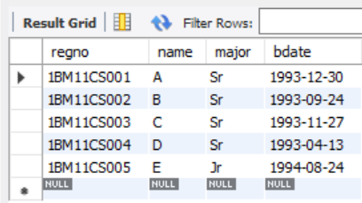

INSERT INTO course VALUES(111,'OS','CSE');

INSERT INTO course VALUES(112,'EC','ECE');

INSERT INTO course VALUES(113,'SS','ISE');

INSERT INTO course VALUES(114,'DBMS','CSE');

INSERT INTO course VALUES(115,'SIGNALS','ECE');

COMMIT;

SELECT * FROM course;

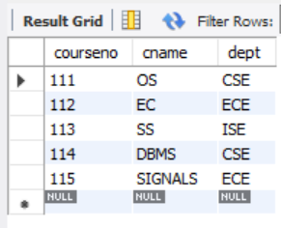

INSERT INTO textbook VALUES(10,'DATABASE SYSTEMS','PEARSON','SCHIELD');

INSERT INTO textbook VALUES(900,'OPERATING SYSTEMS','PEARSON','LELAND');

INSERT INTO textbook VALUES(901,'CIRCUITS','HALL INDIA','BOB');

INSERT INTO textbook VALUES(902,'SYSTEM SOFTWARE','PETERSON','JACOB');

INSERT INTO textbook VALUES(903,'SCHEDULING','PEARSON','PATIL');

INSERT INTO textbook VALUES(904,'DATABASE SYSTEMS','PEARSON','JACOB');

INSERT INTO textbook VALUES(905,'DATABASE MANAGER','PEARSON','BOB');

INSERT INTO textbook VALUES(906,'SIGNALS','HALL INDIA','SUMIT');

COMMIT;

SELECT * FROM textbook;

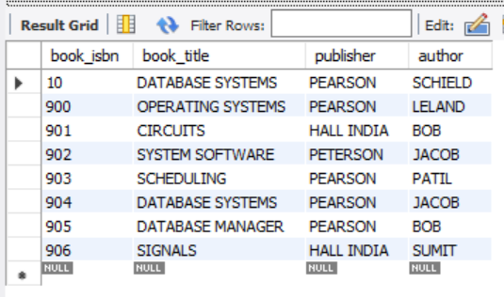

INSERT INTO enroll VALUES('1BM11CS001',115,3,100);

INSERT INTO enroll VALUES('1BM11CS002',114,5,100);

INSERT INTO enroll VALUES('1BM11CS003',113,5,100);

INSERT INTO enroll VALUES('1BM11CS004',111,5,100);

INSERT INTO enroll VALUES('1BM11CS005',112,3,100);

COMMIT;

SELECT * FROM enroll;

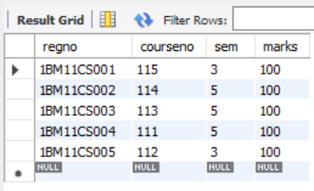

INSERT INTO book_adoption VALUES(111,5,900);

INSERT INTO book_adoption VALUES(111,5,903);

INSERT INTO book_adoption VALUES(111,5,904);

INSERT INTO book_adoption VALUES(112,3,901);

INSERT INTO book_adoption VALUES(113,3,10);

INSERT INTO book_adoption VALUES(114,5,905);

INSERT INTO book_adoption VALUES(113,5,902);

INSERT INTO book_adoption VALUES(115,3,906);

COMMIT;

SELECT * FROM book_adoption;

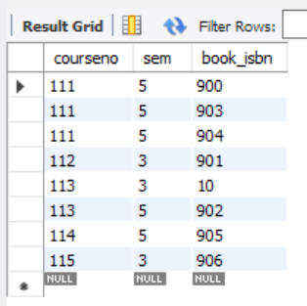

QUERIES:

1. Demonstrate how you add a new text book to the database and make this book be adopted by some department.

INSERT INTO textbook VALUES(908,'UNIX CONCEPTS','TATA MCGRAW HILL','SUMITABHA DAS');

INSERT INTO book_adoption VALUES(113,4,908);

SELECT * FROM textbook;

SELECT * FROM book_adoption;

textbook table:

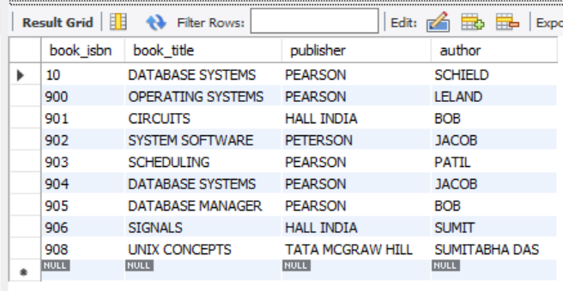

book_adoption table:

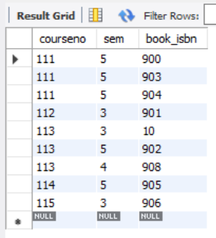

1. Produce a list of text books (include Course #, Book-ISBN, Book-title) in the alphabetical order for courses offered by the ‘CS’ department that use more than two books.

SELECT c.courseno,t.book_isbn,t.book_title

FROM course c,book_adoption ba,textbook t

WHERE c.courseno=ba.courseno

AND ba.book_isbn=t.book_isbn

AND c.dept='CSE'

AND 2<(SELECT COUNT(book_isbn)

FROM book_adoption b

WHERE c.courseno=b.courseno)

ORDER BY t.book_title;

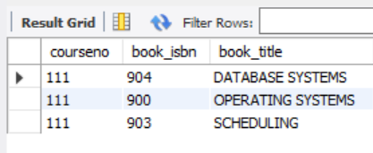

1. List any department that has all its adopted books published by a specific publisher.

SELECT DISTINCT c.dept

FROM course c

WHERE c.dept IN

(SELECT c.dept

FROM course c,book_adoption b,textbook t

WHERE c.courseno=b.courseno

AND t.book_isbn=b.book_isbn

AND t.publisher='PEARSON')

AND c.dept NOT IN

(SELECT c.dept

FROM course c,book_adoption b,textbook t

WHERE c.courseno=b.courseno

AND t.book_isbn=b.book_isbn

AND t.publisher != 'PEARSON');

